**Orthogonal Array Testing Technique (OATS) example:**

**Example 1:**

**Source: www.softwaretestinghelp.com**

Let us consider you have to identify the test cases for a Web Page that has 4 sections: Headlines, details, references and Comments, that can be displayed or not displayed or show Error message. You are required to design the test condition to test the interaction between different sections.

**In this case:**

**1**. Number of independent variables (factors) are = 4

**2**. Value that each variable can take = 3 values (displayed, not displayed and error message)

**3**. Orthogonal array would be 34.

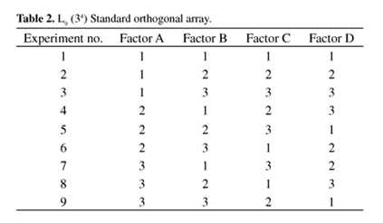

**5**. Now, map this array with our requirements as below:

* 1 will represent “Is Displayed” value
* 2 will represent “not displayed” value
* 3 will represent “error message value”
* Factor A will represent “ Headlines” section
* Factor B will represent “Details” section
* Factor C will represent “references ”section
* Factor D will represent “Comment” section.
* Experiment no will represent “Test Cases #”

**6**. After mapping, the table will look like:

[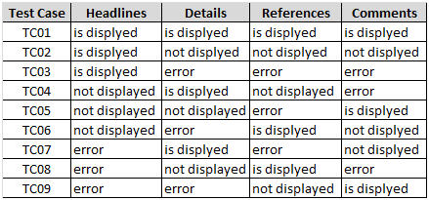](https://cdn.softwaretestinghelp.com/wp-content/qa/uploads/2014/09/Combinational-test-technique-2.jpg)

**7**. Based on the table above, design your test cases. Also look out for the special test cases / left over test cases.

**Example 2:**

**Source : Guru99.com**

A Web page has three distinct sections (Top, Middle, Bottom) that can be individually shown or hidden from user

* No of Factors = 3 (Top, Middle, Bottom)
* No of Levels (Visibility) = 2 (Hidden or Shown)
* Array Type = L4(23)

(4 is the number of runs arrived after creating the OAT array)

If we go for Conventional testing technique, we need test cases like: 2 X 3 = 6 Test Cases

|  |  |  |
| --- | --- | --- |
| **Test Cases** | **Scenarios** | **Values to be tested** |
| Test #1 | HIDDEN | Top |
| Test #2 | SHOWN | Top |
| Test #3 | HIDDEN | Bottom |
| Test #4 | SHOWN | Bottom |
| Test #5 | HIDDEN | Middle |
| Test #6 | SHOWN | Middle |

If we go for OAT Testing we need: 4 Test cases as shown below:

|  |  |  |  |
| --- | --- | --- | --- |
| **Test Cases** | **TOP** | **Middle** | **Bottom** |
| Test #1 | Hidden | Hidden | Hidden |
| Test #2 | Hidden | Visible | Visible |
| Test #3 | Visible | Hidden | Visible |
| Test #4 | Visible | Visible | Hidden |

**Example 3:**

**Source : Guru99.com**

A microprocessor's functionality has to be tested:

1. Temperature: 100C, 150C and 200C.
2. Pressure : 2 psi,5psi and 8psi
3. Doping Amount :4%,6% and 8%
4. Deposition Rate : 0.1mg/s , 0.2 mg/s and 0.3mg/s

By using the Conventional method we need = 81 test cases to cover all the inputs. Let's work with the OATS method:

No. of factors = 4 (temperature, pressure, doping amount and Deposition rate)

Levels = 3 levels per factor (temperature has 3 levels-100C, 150C, and 200C and likewise other factors too have levels)

Create an array as below:

**1. Columns with the No. of factors**

|  |  |  |  |  |
| --- | --- | --- | --- | --- |
| **Test case #** | **Temperature** | **Pressure** | **Doping amount** | **Deposition rate** |

**2. Enter the number of rows as equal to levels per factor. i.e temperature has 3 levels. Hence, insert 3 rows for each level for temperature,**

|  |  |  |  |  |
| --- | --- | --- | --- | --- |
| **Test case #** | **Temperature** | **Pressure** | **Doping amount** | **Deposition rate** |
| 1 | 100C |  |  |  |
| 2 | 100C |  |  |  |
| 3 | 100C |  |  |  |
| 4 | 150C |  |  |  |
| 5 | 150C |  |  |  |
| 6 | 150C |  |  |  |
| 7 | 200C |  |  |  |
| 8 | 200C |  |  |  |
| 9 | 200C |  |  |  |

**3. Now split up the pressure, doping amount and the deposition rates in the columns.**

For e.g.: Enter 2 psi across temperatures 100C,150C and 200C likewise enter doping amount 4% for 100C,150C and 200C and so on.

|  |  |  |  |  |
| --- | --- | --- | --- | --- |
| **Test case #** | **Temperature** | **Pressure** | **Doping amount** | **Deposition rate** |
| 1 | 100C | 2 psi | 4% | 0.1 mg/s |
| 2 | 100C | 5 psi | 6% | 0.2 mg/s |
| 3 | 100C | 8 psi | 8% | 0.3 mg/s |
| 4 | 150C | 2 psi | 4% | 0.1 mg/s |
| 5 | 150C | 5 psi | 6% | 0.2 mg/s |
| 6 | 150C | 8 psi | 8% | 0.3 mg/s |
| 7 | 200C | 2 psi | 4% | 0.1 mg/s |
| 8 | 200C | 5 psi | 6% | 0.2 mg/s |
| 9 | 200C | 8 psi | 8% | 0.3 mg/s |

Hence, in OAs, we need 9 Test cases to cover.